Ex. No.: 6

Date:

SELECT with various clause – GROUP BY, HAVING, ORDER BY

1. Retrieve Name, Gender, MobileNo of all the students in ascending order of RegNo

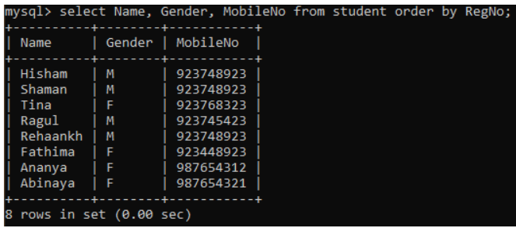

1. List the faculty members in the order of older faculty first.

